Solera Case Submission GuidEline
Solera service desk
- Table of Contents
- Overview 2
- Ways to Request Support 2
- Customer Portal 2
Submitting a Case 2
Logging into Solera’s Customer Support Portal – Customer Portal 2
Requesting Access to the Customer Portal 2
Dashboard 3
Accessing the Knowledge Base 3
Submit a Case 3
Checking Case Status 6
My Cases Page 7
Updating the Case 8
Case Resolution 10
Reset your Password 11

Overview
This guide will demonstrate how to request support or report an incident with Solera and detail the process of submitting a helpdesk case online.

Ways to Request Support
As a customer of Solera solutions, there are three options for requesting support or reporting an incident. They are: submitting a case online, calling the support desk or e-mailing the support desk directly.

Customer Portal

Submitting a Case

Submitting a case is the preferred way of requesting support and reporting issues to Solera. When you are provided access to a Solera solution, you are also provided credentials to access the Customer Portal. Additionally, anyone who works within an organisation that uses a Solera solution can request access to the Customer Portal to request support and report incidents.

Logging into Solera’s Customer Support Portal – Customer Portal

To access the Customer Portal website, you need to enter the URL https://Solera-online.force.com/SoleraPortal into your preferred web browser.

Requesting Access to the Customer Portal

There are three ways to request access to the Customer Portal.
- Have an existing user create a case using the Customer Portal to request access.
- Send an email to Solera Support
- Call the Support Desk.

Once enabled, Customer will receive a "Welcome to the Customer Portal" email that includes a link that allows you to set your password for the portal.
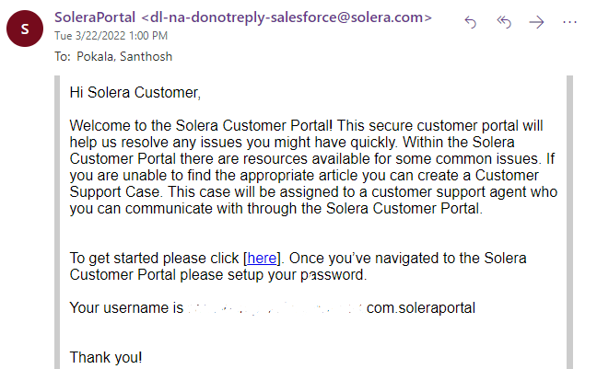

Dashboard

When logging into the Customer Portal you are presented with the dashboard. From this screen you can ‘Submit a Case, ‘Access the Knowledgebase’ and ‘Check Status’.

Accessing the Knowledge Base

Once logged into the Customer Portal, you can access the Knowledge Base. This section provides user guides, learning videos and general documentation around Solera related products. Type your question in the Search field and click the magnifying glass icon.

Submit a Case

To submit a case, click on the Create a Case button at the bottom of the page. See below:
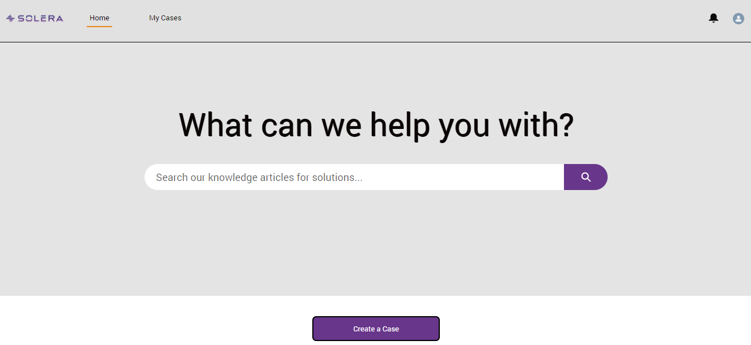

Once selected, type the subject in the Subject field. Next, input information about the issue you are experiencing in the Description field. It is best practise to be as thorough as possible. Click the Product field to search for the product you wish to request support for or report an incident against.
Note: You need to type at least the first three characters of the product name and click on the Product or press enter to see the full list that starts with those 3 characters.
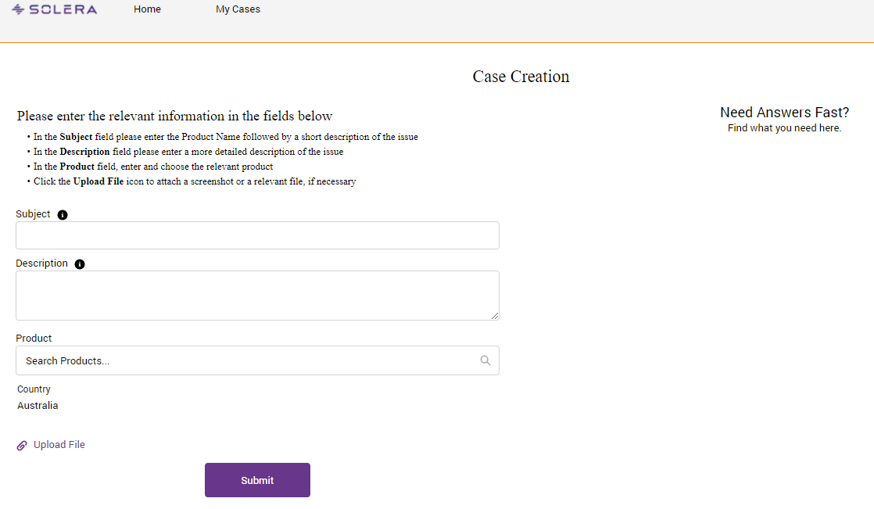

Click the Upload File button or one of the other links to locate the attachment(s). Select the attachment(s) and click the Add button.

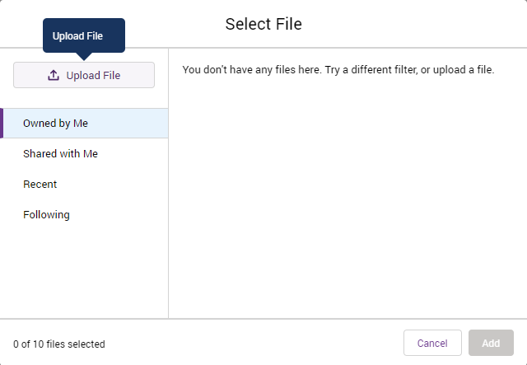

Once all information has been input click the Submit button at the bottom of the page.
Once submitted a message shows you the Case Number.
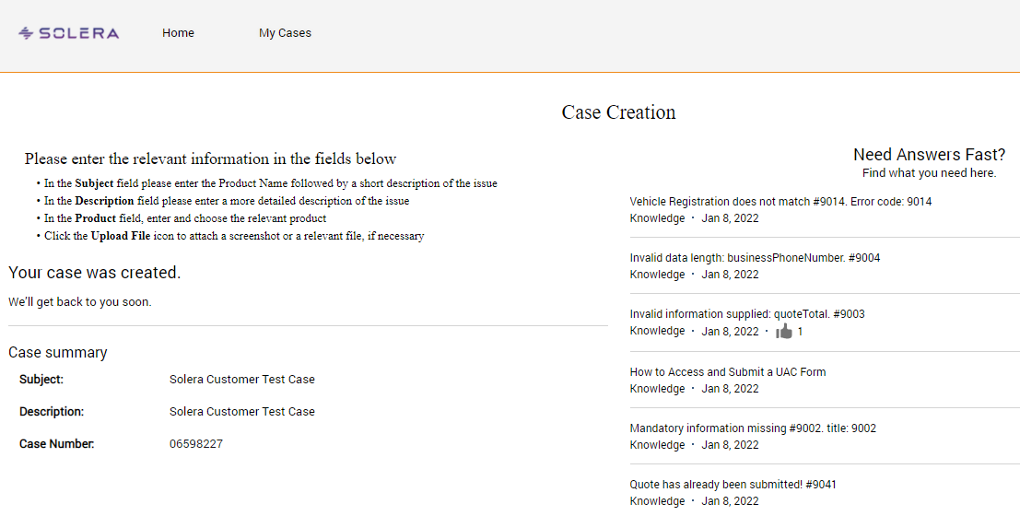

Once the case is created, an auto email will be sent with the case details. See below:
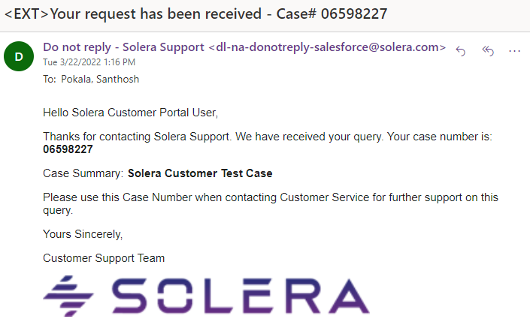

In the email, you are provided a unique incident number. This number is now a reference point if you were to call Solera for an update on your service request or incident. Reference this unique number and any support agent you speak with will be able to assist.

Checking Case Status

After a case has been submitted, the status can be checked by clicking the Case Number or directly from the dashboard by clicking the My Cases link at the top of the page.
Once you click the case number link you can see the Details of the case including the
- Case Comments
- Attachments
- Articles

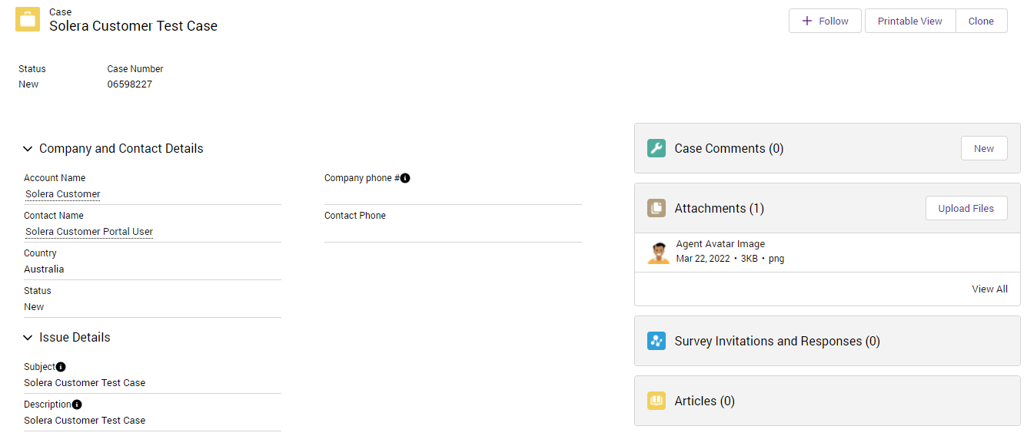

My Cases Page

Click the Cases drop-down menu to filter the case list.
Current and historical cases have different views
- Customer Portal-My Cases: Shows all active and historical cases created by the logged
in customer.
- Customer Portal-All Cases: Shows all active and historical cases created by everyone in
the company.

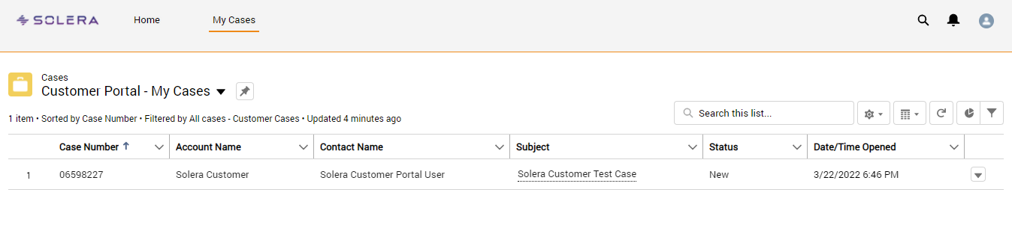

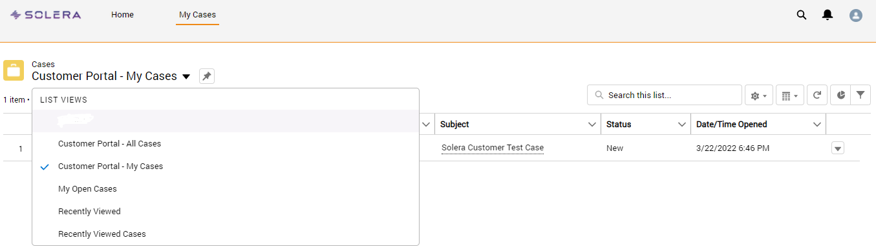

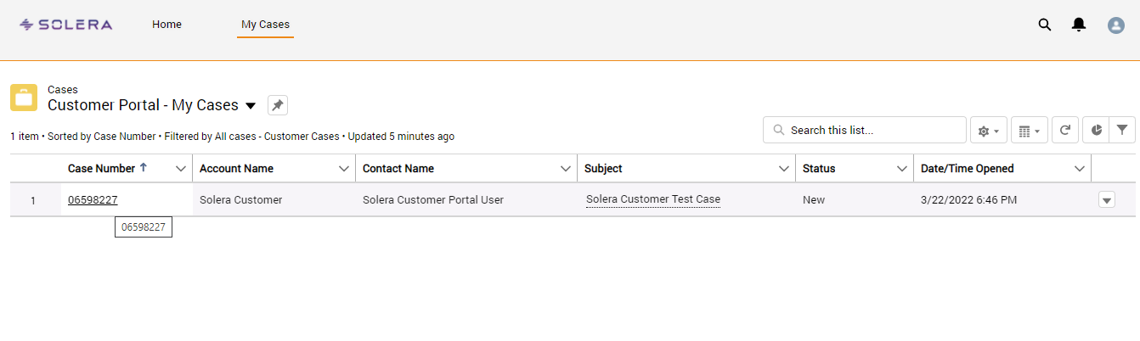

Click on the Case Number to see the Complete Case Details

You can see the below case information in the case detail page:
- Case Number
- Subject
- Status
- Company Name
- Contact Name
- Company Phone
- Contact Phone
- Country
- Description
- Resolution

Updating the Case

You can use the Case Comments section to add updates to the case or view any comments added by the support agent.

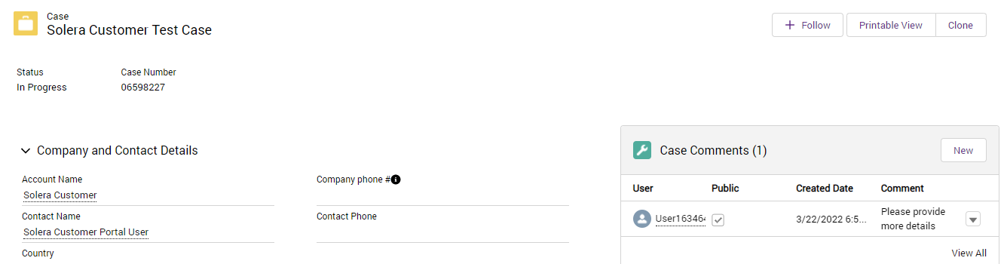

You can add new attachments or view any attachments added by the support agent in the Attachments section.
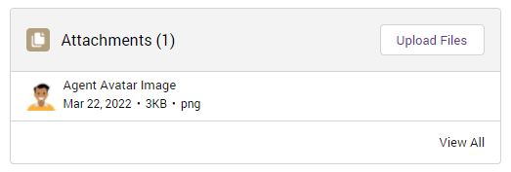

You can see any articles attached to the case by the support agent in the Articles section.
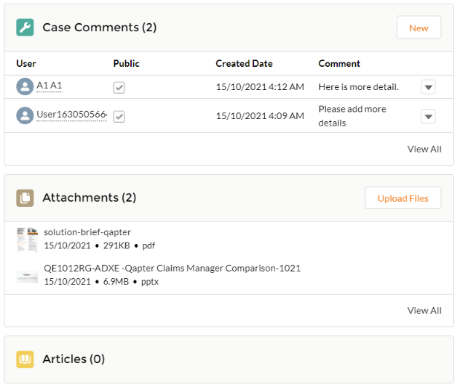

Case Resolution

When your request has been actioned and marked as resolved, an email is sent advising of the resolution. The email will contain any resolution notes as to the reason why the case has been resolved. See image below.
When the issue reoccurs or is not resolved, either reply to the email or add a comment to the case in the Customer Portal.
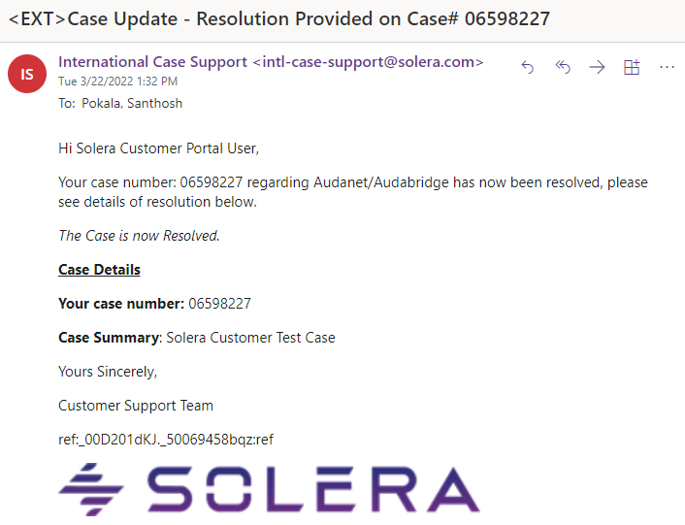

When the case is closed, an email will be sent with a survey.

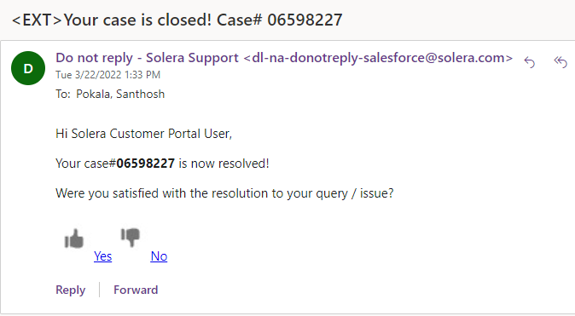

Reset your Password

When you have forgotten your password, you will be able to reset it from the Customer Portal log in page by selecting on the Forgot your Solera Service Desk Password link.
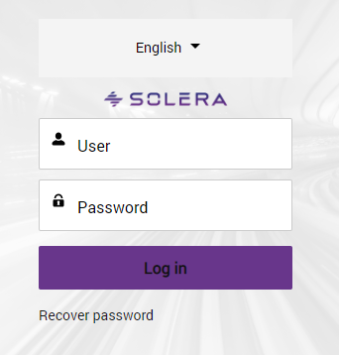
Once selected, you will be redirected to a new page asking for your Username. Once this information has been entered, click the Reset Password button.
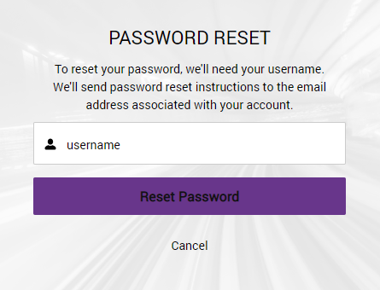
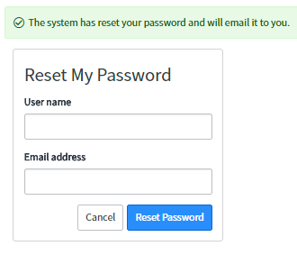
Once the ‘Reset Password’ button has been selected, you will be emailed a temporary password. This page will also advise you that your password has been reset.
Once you log in with your new password, you will need to reset it.

We are continually striving to improve the services we deliver to you. The features described above include those that have been put forward by the insurer and repairer community as well as ideas and suggestions put forward by the Solera team. We welcome your feedback on the products and services we provide so that we can continue to improve the services we deliver to you.

